Atom Developer's Guide
Whilst all reasonable care has been taken to ensure that the details are true and not misleading at the time of publication, no liability whatsoever is assumed by Automature LLC, or any supplier of Automature LLC, with respect to the accuracy or any use of the information provided herein.
Any license, delivery and support of software require entering into separate agreements with Automature LLC.
This document may contain confidential information and may not be modified or reproduced, in whole or in part, or transmitted in any form to any third party, without the written approval from Automature LLC.
Copyright © 2012 Automature LLC
All rights reserved.
Revision History
Ver. | Date | Name | Description of Changes
1.0 | 01/06/12 | Dipayan Sengupta | First Edition
1.1 | 15/06/12 | Dipayan Sengupta | Second Edition
1.2 | 21/06/12 | Dipayan Sengupta | Revised Edition
Contents
1 Introduction 4
1.1 Document Purpose 4
1.2 Intended Audience 4
1.3 References and Other Related Documents 4
2 Dependencies 5
2.1 Zug SDK distribution: 5
3 Writing C# in-process Atoms 6
3.1 Creating a new project 6
3.2 Accessing ZugLib methods 7
3.3 Configuring the Assembly Information 8
3.4 Writing a Class File 9
3.5 Architectural Mechanism for calling C# dll atoms 10
3.5 Accessing ZugLib methods 10
3.5.1 Accessing Context Variable 10
3.5.2 Writing Debug Messages 10
3.5.3 Exception Handling 10
3.6 Writing a simple atom 11
3.7 Build the project 11
3.8 Register the dll 11
3.9 Configuring the ZugINI.xml file 12
3.10 Writing a simple test case 13
4 Writing Java in-process atoms 14
4.1 Create a project 14
4.2 Accessing the ZugLib methods 15
4.3 Writing a Class File 16
4.4 Architectural Mechanism for calling Java atoms 17
4.5 Accessing ZugLib methods 17
4.5.1 Accessing Context Variable 17
4.5.2 Writing Debug Messages 17
4.5.3 Exception Handling 17
4.6 Writing a simple atom 18
4.7 Build the project 18
4.8 Configuring the ZugINI.xml file 19
4.9 Writing a simple test case 19

Introduction

- Atoms in Zug, are the basic reusable units of work. They are entities, such as functions, procedures, programs, or scripts that can be executed either within the context of a main program, or as a standalone program at the command line level in a shell (e.g. the Command Prompt in Windows).

- Atoms are intended to be generic enough, so that they can be applied in test case design in a range of situations. When executing as a standalone program, they are called out-of-process atoms. When implemented as a function or method, they are referred to as in-process atoms, since they can be invoked within the process context of the execution engine.

- Atoms allow users of Zug to extend the functionality of the engine, to apply it to testing different kinds of applications in new domains.

1.1 Document Purpose

This document provides detailed information about developing in-process atoms in various languages e.g. Java, C, C++, C#.

1.2 Intended Audience

This Reference Manual is intended for test case designers and programmers, and assumes prior knowledge of a high level language It also assumes a good understanding of the development and target platform environments.

1.3 References and Other Related Documents

The following documents provide additional useful information about Automature's other products, and how they relate to Zug.

1. Zuoz Reference Guide
2. Chur Programmer's Guide

Dependencies

Before running ZUG on a computer, it has to meet some basic requirements:
Operating System – Microsoft Windows XP or higher
Software – Java(TM) SE Runtime Environment 1.6
NetBeans IDE 7.0
Microsoft Visual Studio 2008 or higher.

2.1 Zug SDK distribution:

Zug SDK is distributed with the standard Zug kit. However, one does not require a run-time license to use it as an SDK. For testing purposes however, it is recommended to ask Automature for a “free” developer license.

Writing C# in-process Atoms

Kindly follow the following steps :

3.1 Creating a new project

Create a new project in Visual Studio. ( Ex.- DemoProject)

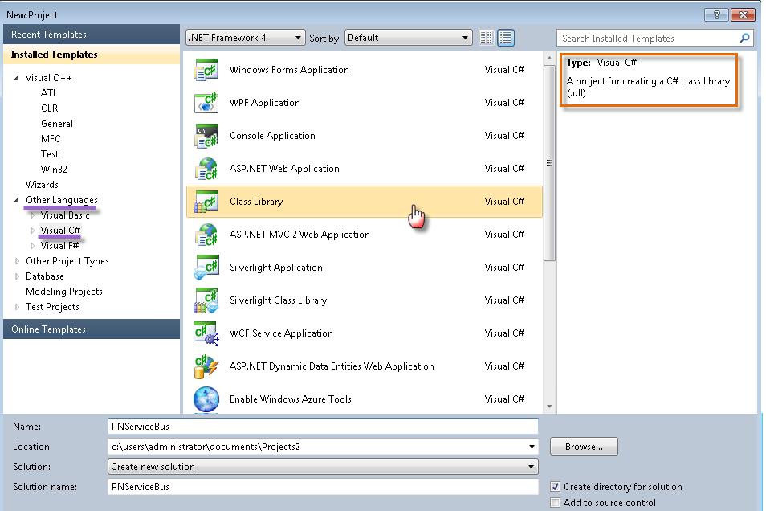

3.2 Accessing ZugLib methods

You have to add a reference to the ZugLib.dll (located in the SDK folder in Zug installation directory) to your custom C# project.
This will expose the ZugLib methods in your project.

Right Click on the References option in the Solution Explorer.

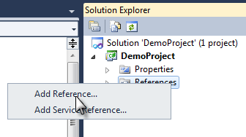

Browse to the Zug installation directory, Navigate to SDK/COM and you will find ZugLib.dll.

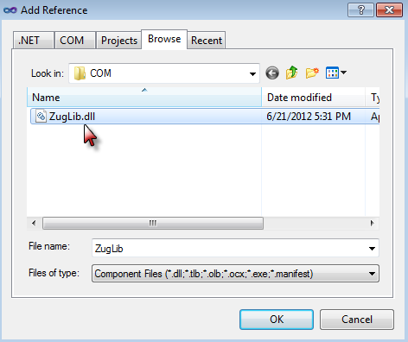

3.3 Configuring the Assembly Information

You need to give the assembly information before writing the class file.

[ComVisible(true), Guid("b33b95fb-b977-4e2c-836a-64d33da85382"), ClassInterface(ClassInterfaceType.None), ComSourceInterfaces(typeof(IZugAtomExecutor))]
ProgId("Automature.DemoProject")]

You need to configure the GUID and also set the ProgID before you write the class file.

Right Click on the Project Name and Select Properties.

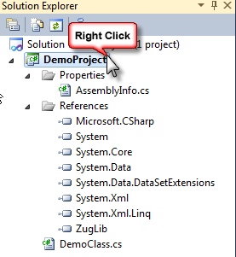

Click on Assembly Language. Select the check box stating Make assembly COM-visible and copy the GUID and replace it in the code stated above.

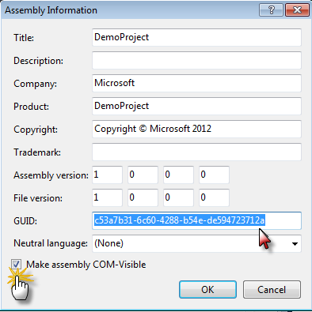

3.4 Writing a Class File

You will need to import the following libraries additionally as mentioned below:

using System.Runtime.InteropServices;
using System.Reflection;
using Automature.Zug;

You will have to implement the dispatch method inside your custom class. The signature of the Dispatch method is as follows:

int dispatch(string method_name, String inputs);

Following is the dispatch method:

public class DemoClass : IZugAtomExecutor
{
public void dispatch(string method_name, string inputs)
ParameterInfo[] args;
bool method_found_flag = false;
bool arg_match_flag=false;
try
{
PNServiceBus iClass = new PNServiceBus();
Type PNSBObj = iClass.GetType();
MethodInfo[] iMethods = PNSBObj.GetMethods();
Object[] iParams = ZugLib.DelimitArg(inputs);
foreach (MethodInfo lMethod in iMethods)
{
if (lMethod.Name.ToUpper().Equals(method_name.ToUpper()) )
{
method_found_flag = true;
args = lMethod.GetParameters();
if (iParams.Length == args.Length)
{
arg_match_flag = true;
lMethod.Invoke(iClass, iParams);
break;
}
}
}

if (!method_found_flag)
{
throw new Exception("Method not found : " + method_name);
}
if (!arg_match_flag)
{
throw new Exception("Argument mismatch : " + method_name);
}
}

catch(Exception e)
{
Console.WriteLine("Message from dispatch ::" + e.InnerException); prints the root cause just as in getCause in Java
ZugLib.Log("error", "error occured while invoking dispatch");
throw e;
}
}

3.5 Architectural Mechanism for calling C# dll atoms

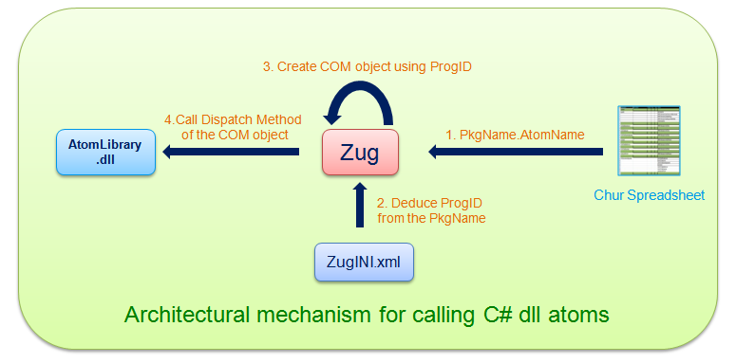

3.5 Accessing ZugLib methods

3.5.1 Accessing Context Variable
In order to access context variable methods from atoms you need to write

ZugLib.SetContextVar(contextvar name, contextvar value)

3.5.2 Writing Debug Messages

In order to write debug messages from atoms you need to write
ZugLib.(“loglevel”.message)

This “loglevel” can be “error” or “debug” or “info”.

3.5.3 Exception Handling

When an exception occurs in a C# atom it can be handled using the Try and Catch block. The exception should be thrown back.
Please refer to the Section 3.6 which illustrates an example of how to handle Exceptions.

3.6 Writing a simple atom

The following is an example of a simple atom which takes two inputs as text and compares them. It also shows how to handle Exceptions by using the Try and Catch Block.

public void Compare(string First_input, string Second_input)
{
try
{

if (string.Equals(First_input, Second_input, StringComparison.OrdinalIgnoreCase))
{
Console.WriteLine("Strings matched successfully");
}
else
{
ZugLib.Log("error", "Strings do not match");
throw new Exception("Strings do not match");
}
}

catch (Exception e)
{
ZugLib.Log("error", "error occurred while invoking Compare");
throw e;
}

}

3.7 Build the project

Build the project and DemoProject.dll file is created in the project output directory
e.g. - C:\Users\Administrator\Documents\Projects\DemoProject\DemoProject\bin\Debug\DemoProject.dll

3.8 Register the dll

Open the Command Prompt as Administrator and run the following command:

%windir%\Microsoft.NET\Framework\v<framework_version>2.0.50727\RegAsm.exe /verbose /nologo /codebase “<path of the dll file>”

For 64-bit Operating System, rewrite the same as

%windir%\Microsoft.NET\Framework64\v<framework_version>2.0.50727\RegAsm.exe /verbose /nologo /codebase “<path of the dll file>”

Example:

C:\Windows\Microsoft.NET\Framework64\v4.0.30319>RegAsm.exe /verbose /nologo /codebase "C:\Users\Admin\Documents\Visual Studio 2010\Projects\DemoProject\DemoProject\bin\Debug\DemoProject.dll"

The output will be as follows:

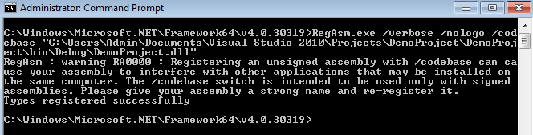

3.9 Configuring the ZugINI.xml file

Inside the Zug Installation directory you will find the ZugINI.xml file.

Please add the following inside <inprocesspackages> tag :

<inprocesspackage name="COMDemo" language="COM">

<prog-id>Automature.DemoProject</prog-id>

</inprocesspackage>

3.10 Writing a simple test case

The following is a simple test case written in Chur. The atom simply compares two strings.

For more information on writing test cases in Chur, please refer to Chur Programmer's Guide.

The output of the test case is as follows:

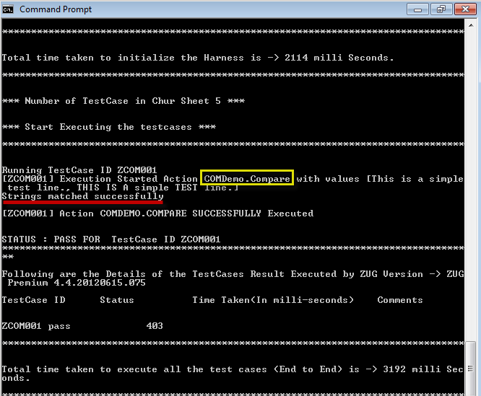

Writing Java in-process atoms

4.1 Create a project

Create a project in NetBeans. (Example – JavaDemo)

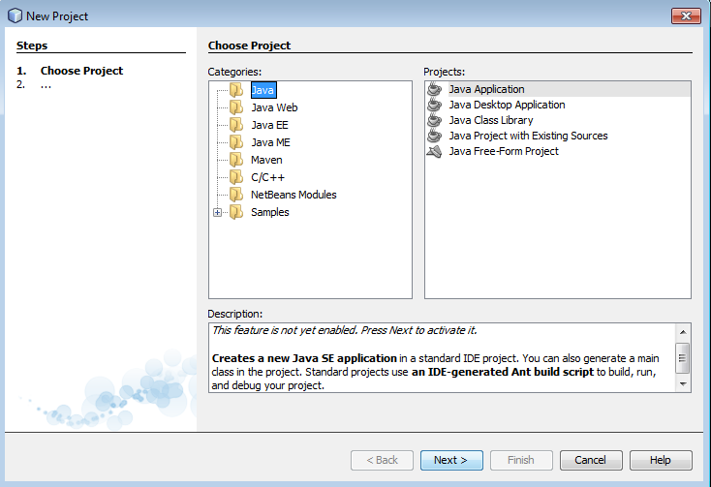

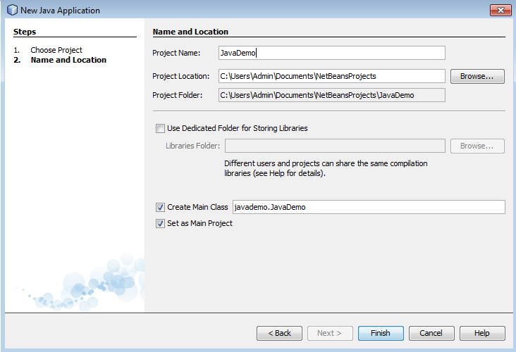

4.2 Accessing the ZugLib methods

You need to add zuglib.jar file to your custom Java project.

Right Click on Libraries and add Jar Folder.

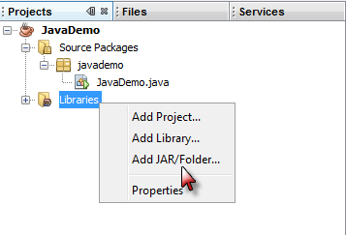

Navigate to the Zug installation Directory where you will find SDK folder. Within the SDK folder, you will find JAVA folder which contains zuglib.jar.

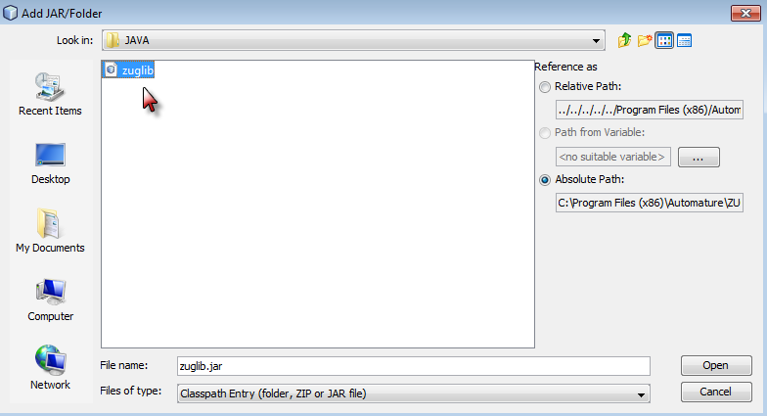

4.3 Writing a Class File

You need to import the following packages:

import com.automature.zug.exceptions.AtomExecutionException;
import com.automature.zug.exceptions.AtomNotFoundException;
import java.lang.reflect.Method;
import com.automature.zug.lib.AtomExecutor;
import com.automature.zug.lib.ZugLib;
import java.lang.reflect.InvocationTargetException;
import java.util.ArrayList;

You will have to implement the dispatch method inside your custom class. Following is the dispatch method:

public class JavaDemo implements AtomExecutor{

public void dispatch(String method_name, ArrayList<String> inputs) throws AtomExecutionException, AtomNotFoundException {
boolean method_found_flag = false, arg_match_flag=false;
try {
Class<?> iClass = Class.forName(this.getClass().getName());
Method[] iMethods = iClass.getMethods();
Object iObject = iClass.newInstance();
Object iParams[] = inputs.toArray();
method_found_flag = false;
for (Method lMethod : iMethods) {
if (lMethod.getName().equalsIgnoreCase(method_name)) {
method_found_flag = true;
if((lMethod.getParameterTypes().length == inputs.toArray().length) || (inputs.isEmpty() && lMethod.getParameterTypes().length==0)){
arg_match_flag = true;
lMethod.invoke(iObject,iParams);
break;
}
}
}
if (method_found_flag && !arg_match_flag) {
throw new AtomNotFoundException("Argument mismatch");
}
if (method_found_flag == false) {
throw new AtomNotFoundException(method_name);
}
}
catch (InvocationTargetException It) {
throw new AtomExecutionException("StringOperation.dispatch\n", It.getCause());
}
catch (Exception e) {
throw new AtomExecutionException("StringOperation.dispatch\n"+e.getClass(), e); }
}
}

4.4 Architectural Mechanism for calling Java atoms

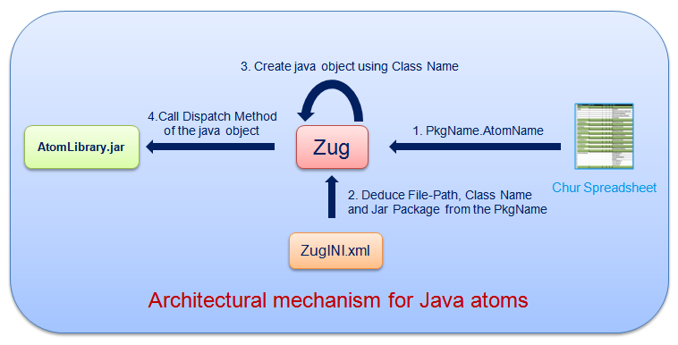

4.5 Accessing ZugLib methods

4.5.1 Accessing Context Variable

In order to access context variable methods from atoms you need to write
ZugLib.SetContextVar(contextvar name, contextvar value);

4.5.2 Writing Debug Messages

In order to write debug messages from atoms you need to write

ZugLib.log(log_level, Message);
This “loglevel” can be “error” or “debug” or “info”.

4.5.3 Exception Handling

When an exception occurs in a Java atom it can be handled using the Try and Catch block. The exception should be thrown back.
Please refer to the Section 4.6 which illustrates an example of how to handle Exceptions.

4.6 Writing a simple atom

The following is an example of a simple atom which takes two input strings and compares them. It also shows how to handle Exceptions by using the Try and Catch Block.

public void compare(String str1, String str2) throws AtomExecutionException
{
String msg = "";
String msg2="";
try {
msg="Error while comparing two strings.";
if (!str1.equalsIgnoreCase(str2)) {
msg="Strings do not match";
throw new Exception("String do not match");
}
else
System.out.println("Strings matched Successfully");

} catch (Exception e) {
ZugLib.log("error",e.getMessage());
}
}

4.7 Build the project

Build the project and JavaDemo.jar file is created in the project output directory

e.g. -C:\Users\Admin\Documents\NetBeansProjects\JavaDemo\dist\JavaDemo.jar

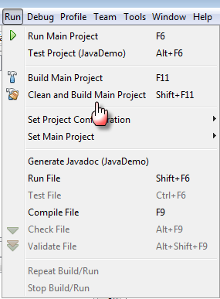

4.8 Configuring the ZugINI.xml file

Inside the Zug Installation directory you will find the ZugINI.xml file.

Please add the following inside <inprocesspackages> tag :

<inprocesspackage language="java" name="Demo">
<file-path>
C:\Users\Admin\Documents\NetBeansProjects\JavaDemo\dist
</file-path>
<jar-package>javademo</jar-package>
<class-name>JavaDemo</class-name>
</inprocesspackage>

4.9 Writing a simple test case

The following is a simple test case written in Chur. The atom simply compares two strings.

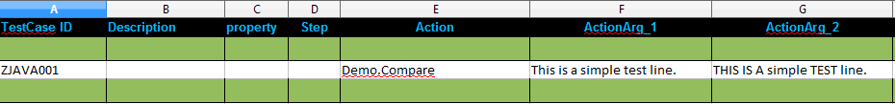

For more information on writing test cases in Chur, please refer to Chur Programmer's Guide.

The output of the test case is as follows:

